**Fitness Companion – Project Description**

**Jaume Lopez Topping 282231**

**Gabriel Moutinho Tristan 304376**

**Lars Bech Sørensen**

**5960 characters**

**Software Technology Engineering**

**7th Semester**

**17-October-2024**

**Table of content**

1. Problem Domain 1

2. Problem statement 2

3. Delimitation 2

4. Choice of methods 3

5. Time schedule 4

6. Risk assessment 5

7. References 6

# Problem Domain

Interest in fitness has increased recently due to health risks linked to sedentary lifestyles, such as obesity and heart disease (Park, 2020). This shift has led to a need for accessible fitness solutions to help people manage their health. With technology making digital fitness apps widely available, their use has grown rapidly.

However, many popular apps, like MyFitnessPal and Fitbit, are focused on keeping users engaged rather than truly supporting health goals. This focus on engagement can lead to manipulative design choices, which may prioritize revenue over meaningful health support (Sax, 2021).

Fitness apps attract users of all fitness levels, from beginners to advanced. Trainers, healthcare professionals, and wellness programs also benefit from these apps to support training, patient care, or employee wellness.

Research suggests that users need personalized feedback and motivation to stay with an app long-term (Grua, 2022). Yet, many current apps struggle to keep users engaged, as they often lack the ability to adapt to individual progress and preferences.

This shows a clear need for a new fitness app that combines personalized guidance and adaptable features. This would help users stay motivated and focused on their health goals, offering real benefits rather than just maximizing engagement.

# Problem statement

**Main Problem:** How can a fitness app effectively address the limitations of current solutions by promoting sustained user engagement and motivation, while prioritizing health-focused outcomes over profit-driven engagement?

**Sub-questions:**

* What are the key factors that drive user motivation and long-term engagement in fitness apps?
* Why do current fitness apps struggle to meet users' health goals and maintain engagement over time?
* How do personalization and adaptability features influence user experience and retention in fitness apps?

# Delimitation

This project will focus on developing a fitness app that addresses key challenges in user engagement and motivation, with an emphasis on personalization, adaptability and ethical design. The app will be designed to support long-term user engagement by addressing these specific areas identified as limitations in existing fitness apps.

While trainers, healthcare professionals, and wellness programs may be considered in the design, their roles will be limited to how they can support user engagement within the app.

# Choice of methods

This project will apply the waterfall development method to create a fitness app that addresses user engagement, motivation, and ethical design. Each phase will be completed sequentially to ensure a structured and thorough approach.

1. **Knowledge and Data Collection**

In the initial phase, a literature review will be conducted to gather insights on user motivation, personalization, and ethical engagement in fitness apps. This review will focus on existing research and case studies to understand best practices and common challenges in fitness app design.

1. **Requirements Analysis**

Based on insights from the literature review, specific requirements for the app’s design and functionality will be defined. This phase will focus on translating research findings into actionable requirements that guide the app’s development. Key considerations will include factors that enhance user engagement, motivation, and ethical use.

1. **Design and Modeling**

During the design phase, Astah will be used to create UML diagrams for system modeling, providing a visual representation of the app’s structure, workflow, and feature integration. Additionally, wireframing and prototyping tools, such as Figma, will be used to design the app’s interface, ensuring a user-centered approach that prioritizes ease of use and engagement.

1. **Development and Construction**

Following the detailed design, the app will be developed in line with the specifications outlined. The waterfall approach will be used to complete each feature in sequence, verifying functionality and ensuring that each component aligns with the established requirements.

1. **Testing**

After the app is developed, usability testing will be conducted to assess functionality and user experience. This testing will focus on verifying that the app is intuitive, meets user needs, and aligns with initial requirements for motivation and engagement. Adjustments will be made based on testing results to optimize the app’s performance and user experience.

1. **Project Management**

Throughout the project, waterfall project management techniques will ensure that each phase is fully completed before progressing to the next. Astah will be used to track and document the system’s design and development progress, providing a structured approach to maintain alignment and clarity throughout the project.

# Time schedule

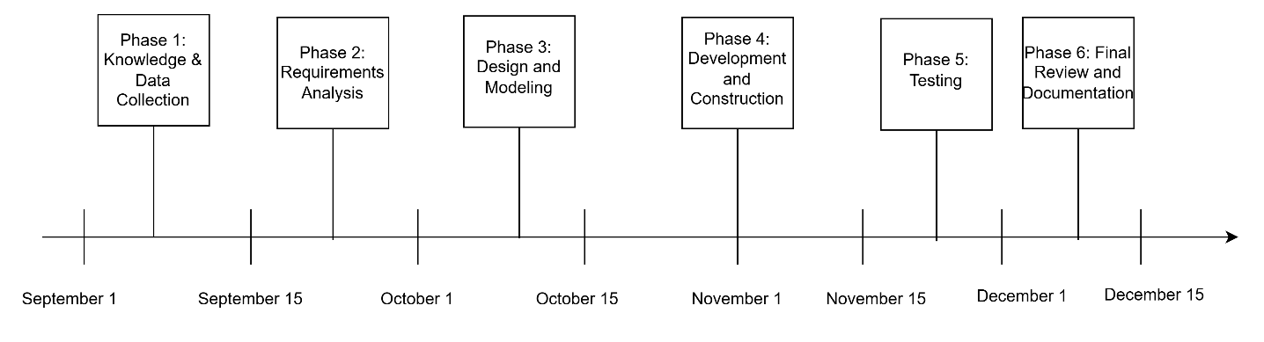

# Risk assessment

|  |  |  |  |
| --- | --- | --- | --- |
| **Risk** | **Likelihood** | **Impact** | **Preventive Action** |
| **Technical Difficulties with Android** | Medium | High | Ensure familiarity with Android through tutorials. |

# References

Grua, E. M. (2022). *Information and Software Technology*. Retrieved November 07, 2024, from https://www.sciencedirect.com/science/article/pii/S0950584922000180

Park, J. e. (2020). *Sedentary lifestyle.: Overview of updated evidence of potential health risks, Korean journal of family medicine*. Retrieved November 07, 2024, from https://pmc.ncbi.nlm.nih.gov/articles/PMC7700832/

Sax, M. (2021). Optimization of what? For-profit health apps as manipulative digital environments. *Ethics and Information Technology, 23*(3), 345-361. Retrieved from https://doi.org/10.1007/s10676-020-09576-6